**УРОК-ПРЕЗЕНТАЦИЯ В 7 КЛАССЕ**

**по теме HALLOWEEN**

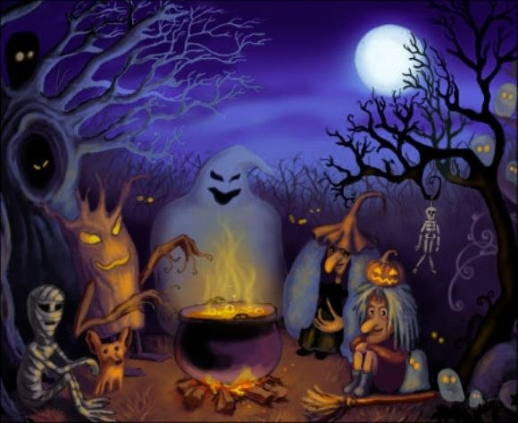

**Цель урока:** обобщить страноведческий материал по теме «Хэллоуин»

**Задачи:** 1.активизация навыков устной речи, аудирования и письма;

2.закрепление навыков изучающего чтения;

3.активизация лексики по теме.

**Оборудование:** медиапроектор, экран, презентация, картинки по теме «Суеверия», раздаточный материал для домашнего чтения.

**Ход урока**

1. **Организационный момент**

У: There many holidays in Great Britain and in the USA. Some of them are national, some- religious. Today we shall speak about Halloween, about its history, customs connecting with holiday. We also speak about different superstitions and find out what superstitions you and your classmates believe in.

1. **Работа с презентацией**

**1-ый слайд** «Из истории праздника»

Учащиеся читают текст и отвечают на вопрос учителя «What does this holiday celebrate?»

**2-ой слайд** Учащиеся прослушивают рассказ учителяо Джеке из Ирландии (для слабых групп можно с опорой на текст) и отвечают на вопросы:

1. **How did Jack deceive the Devil?**
2. **Why couldn’t he get to Paradise after his death?**
3. **What was given to him to brighten his long way in the darkness?**
4. **Why do people use now a pumpkin instead a turnip?**

**3-ий слайд** У: Now you know why we call the Halloween lantern Jack-

O-lantern. The instructions for the lantern are mixed up. Put them in correct

order. (Учащиеся записывают в тетради правильный порядок, затем

работа проверяется. Может один ученик зачитать ее, а можно по одному

пункту.)

**4-ый слайд** У: In the evening there are lots of Halloween’s parties. People

dress up as witches, ghosts, devils, cats or bats.

**5-ый слайд** У: You can hear Song of Halloween on this Day.

**6-ой слайд** У:Some children follow the American custom **Trick or Treat**.

What do you know about this custom? ( Некоторые учащиеся уже знают об

этом обычае, поэтому могут ответить на поставленный вопрос. В случае

затруднения можно сначала текст прочитать.)

**7-ой слайд** Заранее подготовленный ученик рассказывает стихотворение

**Trick or Treat** наизусть.

**8-ой слайд** У: You can see some puzzles connecting with Halloween. Try to

guess them.

**9-ый слайд** У: No Halloween party is complete without a scary story. Usually people crowd together around a fire on Halloween’s night. And one person tells a scary story in a low voice. (Один из учащихся читает историю о Томе Колли)

**10-ый слайд** У: Different people have different superstitions. Have you ever touched the wood? Do you hate the number 13? Do you believe in good luck or bad luck? These are a few British superstitions. (Учащиеся читают высказывания и подбирают соответствующую картинку на доске). Are the superstitions the same in our country?

**11-ый слайд** У: Do you have any superstitions? Now we check. ( Учащиеся читают высказывания и отвечают “yes” or “no”). As you see some of you are superstitious, the others-not)

**12-ый слайд** У: I have got recipes of some tasty things which you can prepare for your Halloween’s party. I can give you them.

1. **Подведение итогов урока**

У: **What new information have you learnt today? What facts were interesting (unusual) for you?**

1. **Объяснение домашнего задания**

У: As I see you like to listen and to read scary stories. For the next lesson of our Home reading you get the following task: read the story, give the title, draw a picture for it. At the next lesson you’ll retell the stories, show pictures. And we’ll choose the best.

**HOMETASK**

**SPOOKY STORIES**

**1)** My brother was riding his motorbike one evening after work. He saw a girl at a bus stop. It was very cold and it was raining, so he offered to take her home. She got on a bike and told him her address. It was quite near our house. At first he tried to ask her a few questions, but she didn’t say anything. He wasn’t surprised because it was windy and noisy on motorbike. They were nearly her home when he stopped at a corner. Suddenly, he felt something was very wrong. She wasn’t holding him anymore. He turned round. She wasn’t there! He went back to the bus stop but he couldn’t find her anywhere.

The next day he was very worried about her, so he went to her home. An old woman opened the door. He said ‘Is your daughter OK? I was bringing her home last night when she disappeared.’ The old women went white and said ‘Young man, my daughter died 7 years ago.’

**2)** On the morning of 19th July 1985 a family in India were waiting for the funeral of their seventeen-year-old daughter, Sumitra. Her body was lying in the family home. Suddenly she opened her eyes!

Her parents couldn’t believe it. Their daughter was alive! They were delighted, but when Sumitra spoke, she couldn’t remember anyone and she said her name was Shiva.

Sumitra’s parents found a family of a girl called Shiva. She died two months before Sumitra ‘died’. When Sumitra went to Shiva’s home, she recognized the family and all the things in the house. She even wrote in the same handwriting and style as Shiva. This was strange because Sumitra couldn’t write at all.

**3)** In December 1984 Ken Webster and Debbie Oaks were living in an old cottage in Cheshire, England. One evening a message appeared on their computer screen from nowhere. They weren’t using the computer. They weren’t even sitting near it at the time. Messages from someone called Thomas Harden.

The message was in a very strange sort of English. They wrote it down. A historian said it was a perfect example of 16th – century English! This was the first of more than 300 messages from someone called Thomas Harden, who lived in the cottage 450 years before. When Ken and Debbie asked questions on the computer, another message answered them. It was incredible.